EXP NO:11 | Study of Metasploit Framework and Windows Exploit Modules
DATE: | Study of Metasploit Framework and Windows Exploit Modules

Aim:

Algorithm:

Program:
# Study of Metasploit Framework and Windows Exploit Modules

print("Metasploit Framework Study")
print("===========================")
print()
print("Commands Used:")
print("1. msfconsole - Start Metasploit console")
print("2. help - Display available commands")
print("3. search type:exploit platform:windows")
print(" - Search Windows exploit modules")
print("4. info [module-name] - Display module information")
print("5. show options - Display module options")
print("6. back - Return to main console")
print("7. exit - Exit Metasploit")
print()
print("Key Commands Studied:")
print(" search -> Search modules")
print(" info -> Display module information")
print(" show -> Display available items/options")
print(" back -> Return from selected module")
print(" exit -> Exit Metasploit")
print()
print("Module Information Fields:")
print(" Module Name")
print(" Description")
print(" Windows versions/services affected")
print(" References")
print(" Targets")
print(" Required Options (RHOSTS, RPORT, TARGET)")
print()
print("Metasploit Framework studied successfully.")

Output:
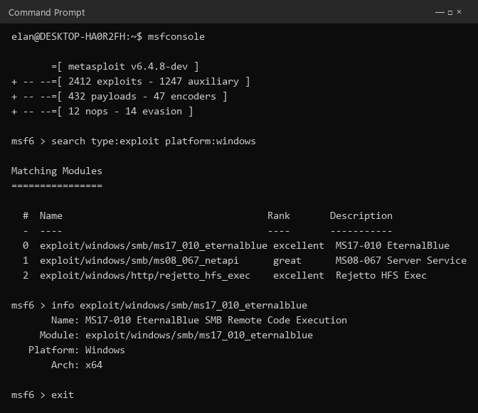

Result:

